Courier Management System (CMS)

User Story:
The Courier Management System is designed to make courier booking and
delivery management simple and efficient. Customers can register their details and
book courier services through the system. The system collects sender and receiver
information along with source and destination details. After booking, a unique
tracking number is provided to the customer. Customers can use this tracking number
to check the current status of their parcel. Administrators can manage customer details,
courier bookings, and delivery status. The system maintains all records digitally and
helps reduce manual paperwork. Overall, the system provides a convenient and
organized way to manage courier services.

1. INTRODUCTION

1.1 Project Overview :

Courier and logistics companies face challenges in efficiently managing shipments and deliveries due to manual operations and disconnected systems. These issues lead to delayed updates, poor customer visibility, and operational inefficiencies.
The Courier Management System (CMS) is a Salesforce-based cloud solution that centralizes shipment booking, tracking, delivery agent assignment, automated status updates, billing, and analytics. The system improves operational efficiency, enhances customer satisfaction, and provides real-time business insights.

1.2 Purpose :

The purpose of the Courier Management System (CMS) is to automate and centralize courier and logistics operations using the Salesforce platform. The system aims to replace manual and fragmented processes with an integrated digital solution that enables efficient shipment booking, real-time tracking, delivery agent assignment, automated notifications, billing, and performance reporting. By providing a single, unified platform for managing shipments across multiple branches, CMS improves operational visibility, enhances customer communication, reduces delays and errors, and supports faster decision-making through analytics. Ultimately, the system is designed to increase service efficiency, customer satisfaction, and overall business profitability.

2. IDEATION PHASE
2.1 Problem Statement (Customer Problem Statement Template)

PS | I am (Customer) | I’m trying to | But | Because | Which makes me feel
PS-1 | Courier  Staff | Update Shipment  Detail quickly | Data entry take more time | Information is maintained manually | frustrated
PS-2 | Delivery staff | Identify the correct parcels for delivery | Parcel details are not easily accessible | There is no centralized shipment database | stressed
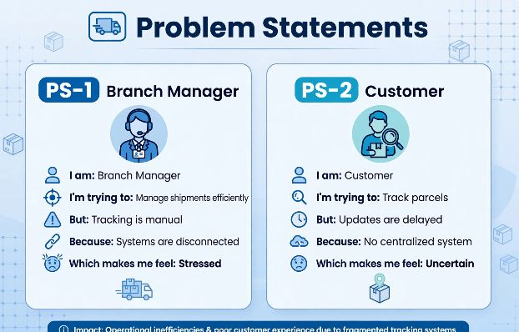

2.2 Empathy Map Canvas
User Persona: Branch Manager
- Think & Feel: Concerned about delays & errors
- Hear: Customer complaints
- See: Registers & spreadsheets
- Say & Do: Manual follow-ups
- Pain: Delivery conflicts & missed updates
- Gain: Automated tracking & dashboards
- 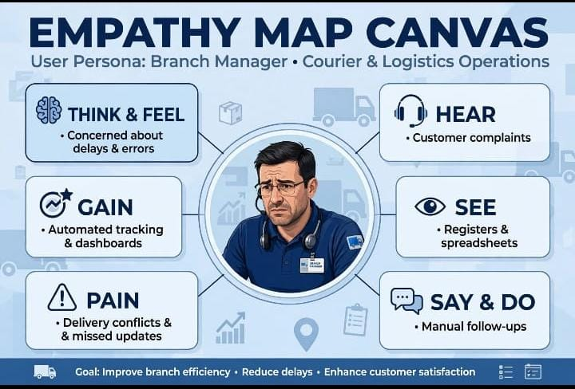

2.3 Brainstorming & Idea Prioritization
Ideas Considered
- Manual registers
- Spreadsheet tracking
- Standalone portal
- Salesforce CRM
Final Selection
- Salesforce CRM selected due to:
- Automation
- Scalability
- Real-time visibility
- 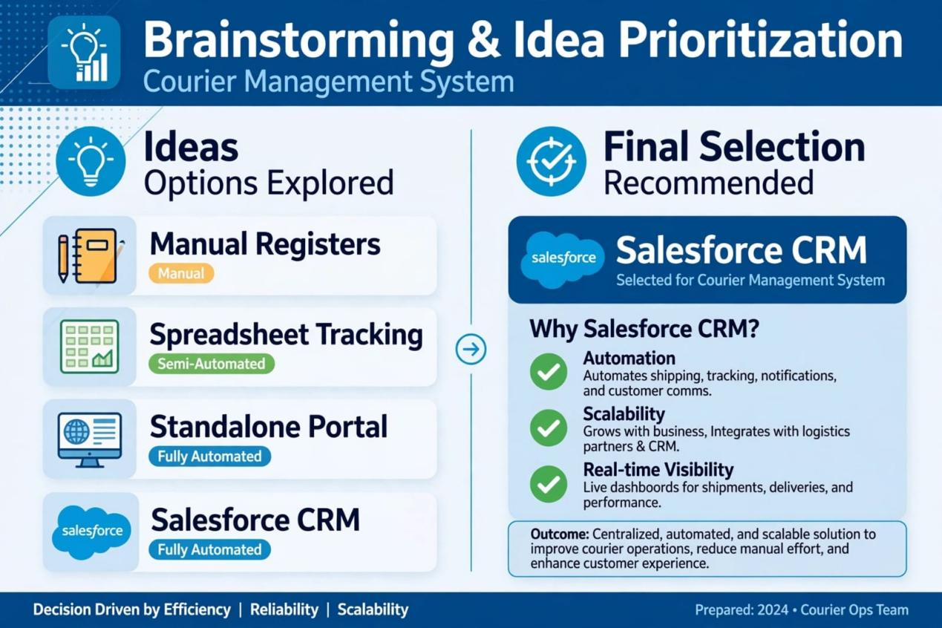

3.REQUIREMENT ANALYSIS PHASE

3.1 Customer Journey Map
Stages:

Booking → Shipment Creation → Agent Assignment → Transit → Delivery Update → Invoice → Reporting
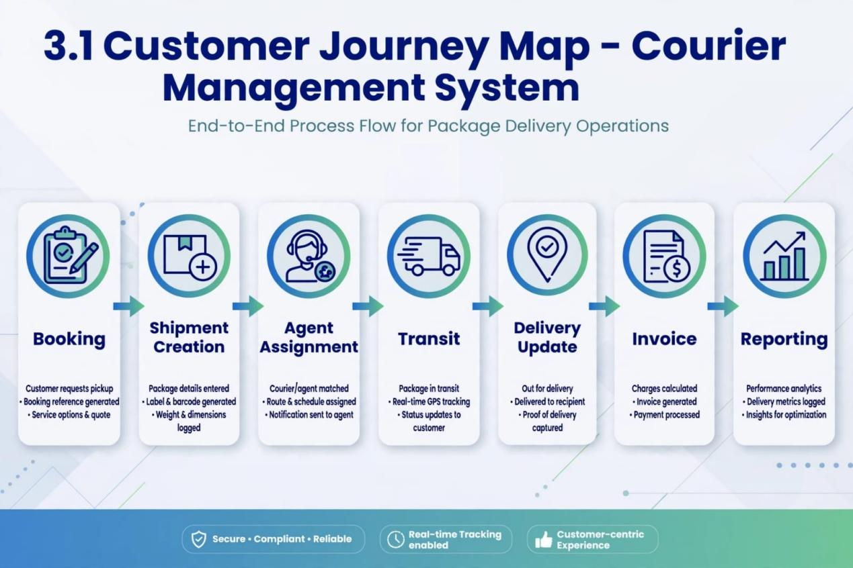
3.2 Solution Requirements
Functional Requirements

FR No | Requirement
FR-1 | Customer management
FR-2 | Shipment booking
FR-3 | Delivery agent assignment
FR-4 | Real-time status updates
FR-5 | Invoice generation
FR-6 | Reports & dashboards

Non-Functional Requirements

NFR | Description
Usability | Easy Lightning interface
Security | Role-based access control
Reliability | Error-free automation
Performance | Fast tracking updates
Availability | 24/7 cloud access
Scalability | Supports growing branches

3.3 Data Flow Diagram
Flow:
Customer Input → Shipment Creation → Validation → Agent Assignment → Delivery Update → Invoice → Reports
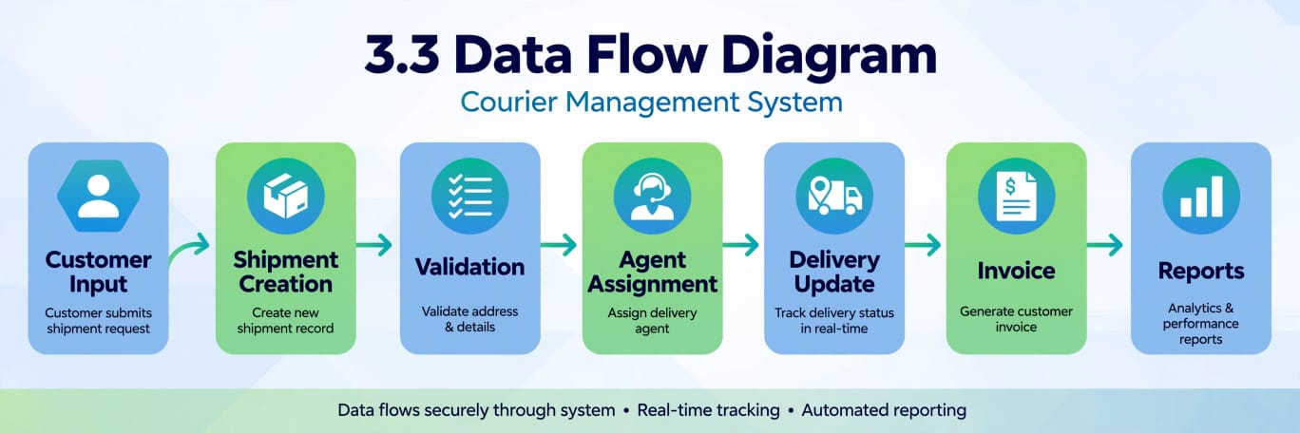
3.4 Technology Stack
Layer | Technology
UI | Salesforce Lightning
Logic | Salesforce Flows
Database | Salesforce Objects
Automation | Validation Rules, Flows
Security | Profiles, Roles
Reporting | Reports & Dashboards

4. PROJECT DESIGN PHASE

4.1 Problem–Solution Fit
CMS eliminates fragmented courier operations by automating shipment tracking, delivery assignment, billing, and reporting within a centralized Salesforce platform.
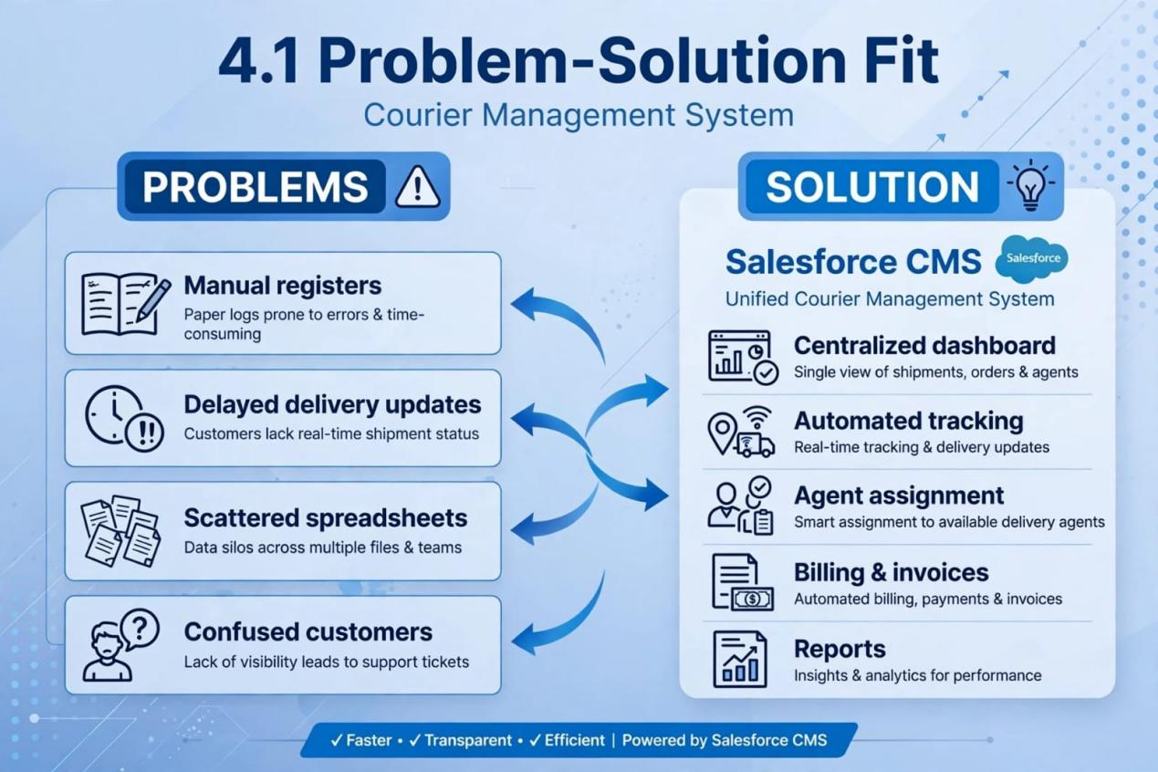
4.2 Proposed Solution
Functional Requirements

Parameter | Description
Problem | Manual shipment management
Solution | Salesforce CMS
Innovation | Automated tracking & billing
Impact | Faster deliveries
Business Model | Courier services
Scalability | Multi-branch ready

4.3 Solution Architecture
- Components:
- Customer Object
- Shipment Object
- Delivery Agent Object
- Branch Object
- Delivery Update Object
- Invoice Object
- Flows
- Reports
- Dashboards
- 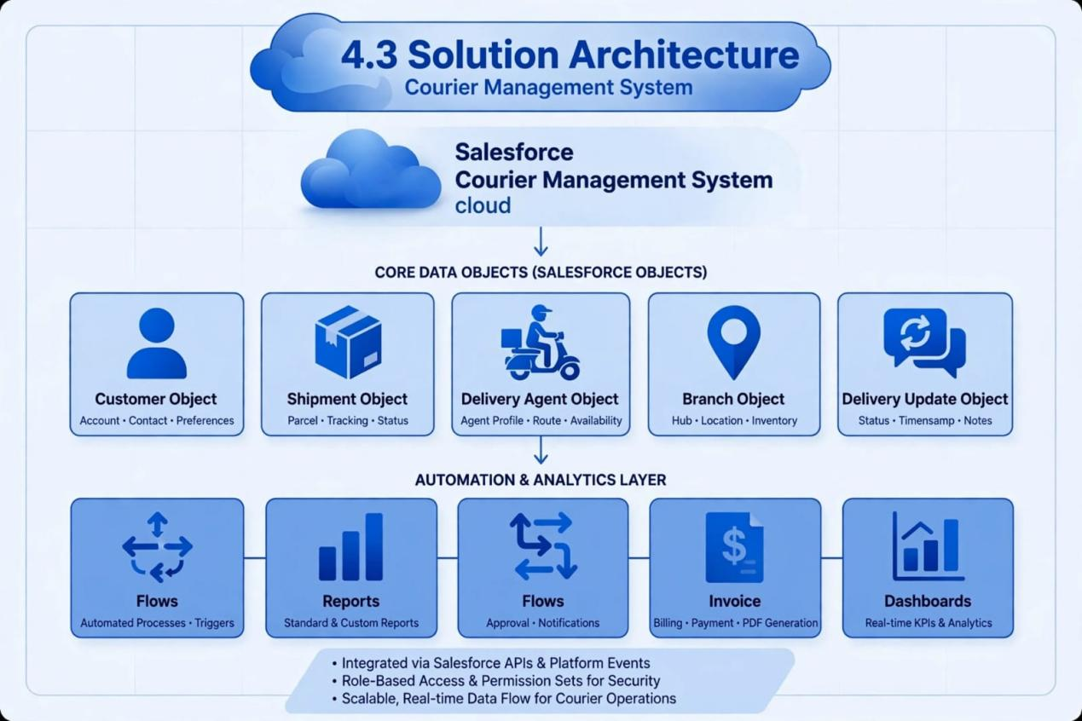

5. PROJECT PLANNING & SCHEDULING

5.1 Project Planning
Agile methodology
Epics → Stories → Story Points
Sprint-based execution
Velocity calculation used for estimation
Product Backlog, Sprint Schedule, and Estimation (4 Marks)
Use the below template to create product backlog and sprint schedule
Sprint | Functional Requirement (Epic) | User Story Number | User Story / Task | Story Points | Priority | Team Members
Sprint-1 | Org Setup | USN-1 | As a salesforce admin,I need to provision developer org&enable CMS features so team can start building courier solution securely | 3 | High | Member1
Sprint-2 | Data Model | USN-2 | As a data architect I need to build 5 custom objects(customer,Shipmentagent,branch,delivery)with relations for student traking | 5 | High | Member2
Sprint-2 | App builder | USN-3 | As a staff member, I want tabs and a Lightning App for all courier modules so that I can easily navigate and perform daily operations. | 5 | High | Member3
Sprint-3 | Automation | USN-4 | As a courier staff, I need a dedicated ligthning app with custom tabs&navigation so I can quickly access daily operation without confusion | 3 | High | Member4
Sprint-3 | analytics | USN-5 | As a dispatcher, I want automated flows for shipment status updates and agent assignment so that deliveries are processed faster without manual intervention. | 3 | High | Member4
Sprint-4 | Billing | USN-6 | As a system,I need record-triggered flows to a auto-assign delivery agents&send status updates so manual efforts is reduced by 80% | 5 | High | Member2

Project Tracker, Velocity & Burndown Chart: (4 Marks)
Sprint | Total Story Points | Duration | Sprint Start Date | Sprint End Date (Planned) | Story Points Completed (as on Planned End Date) | Sprint Release Date (Actual)
Sprint-1 | 20 | 6 Days | 16 sep 2026 | 21 sep 2026 | 20 | 21 sep 2026
Sprint-2 | 20 | 6 Days | 16 sep 2026 | 21 sep 2026
Sprint-3 | 20 | 6 Days | 16 sep 2026 | 21 sep 2026
Sprint-4 | 20 | 6 Days | 16 sep 2026 | 21 sep 2026

6. Project Development Phase:

What you'll learn
1.Real-time Salesforce project implementation
2.Designing custom objects and relationships
3.Creating page layouts & record types
4.Writing validation rules
5.Building automation with flows
6.Developing reports & dashboards
7.Setting up security with profiles, permission sets, and sharing
8.End-to-end application testing

Milestone 1: Salesforce Account
Introduction:
New to Salesforce and unsure where to start? Curious how real business applications—like loan processing and payment tracking—can be built on the platform? You’re in the right place.
Welcome to the Loan Management System project!
Salesforce offers powerful tools that help automate processes, improve accuracy, and manage customer operations with ease. In this project, you’ll learn how Salesforce can streamline lending workflows—from borrower onboarding to loan approval, EMI tracking, and document verification.
What Is Salesforce ?

Salesforce is your customer success platform, designed to help you sell, service, market, analyze, and connect with your customers. Salesforce has everything you need to run your business from anywhere. Using standard products and features, you can manage relationships with prospects and customers, collaborate and engage with employees and partners, and store your data securely in the cloud.

Activity 1: Creating Developer Account
Creating a developer org in salesforce.
1.Go to https://developer.salesforce.com/signup
2.On the sign up form, enter the following details :
3. First name & Last name
4. Email
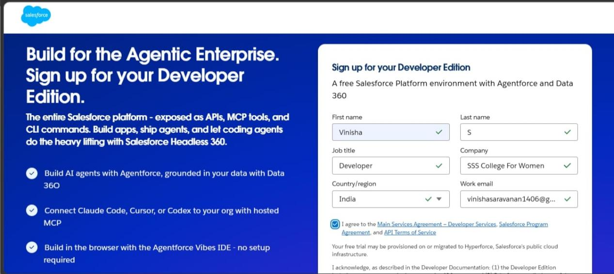
1) First name & Last name
2) Email
3) Job Title: Developer
4) Company: College Name
5)Country: India
Click on sign me up after filling these.

Activity 2: Account Activation
- Go to the inbox of the email that you used while signing up. Click on the verify account to activate your account. The email may take 10-30 mins and sometimes 2 hours.


2. Click on Verify Account
3.Give a password and answer a security question and click on change password.
4.Then you will redirect to your salesforce setup page.


Milestone 2- Object:
What is an object?
Salesforce objects are database tables that permit you to store data that is specific to an
organization. It consists of fields (columns) and records (rows).
Custom Objects Created:
1. Customer__c – stores customer personal and contact information
2. Shipment__c – manages parcel details, source, destination, and tracking information
3. Delivery_Agent__c – maintains delivery agent profiles and branch details
4. Branch__c – represents courier branch offices
5. Delivery_Update__c – stores status updates for each shipment
6. Invoice__c – manages billing details for delivered shipments
Relationships:
Customer → Shipment (Lookup)
Shipment → Delivery_Agent (Lookup)
Delivery_Agent → Branch (Lookup)
Delivery_Update → Shipment (Master-Detail)
Invoice → Shipment (Lookup)
Steps to Implement :

Activity 1: Create Customer Object
Click Setup → Object Manager → Create → Custom Object
Enter the following details:
Label: Customer
Plural Label: Customers
Record Name: Customer Name (Text)
Under Optional Features:
Enable Allow Reports
Enable Track Field History
In Search Status check the box Allow Search
In Object Creation Options check the box Add Notes and Attachments related list to default page layout
Click Save
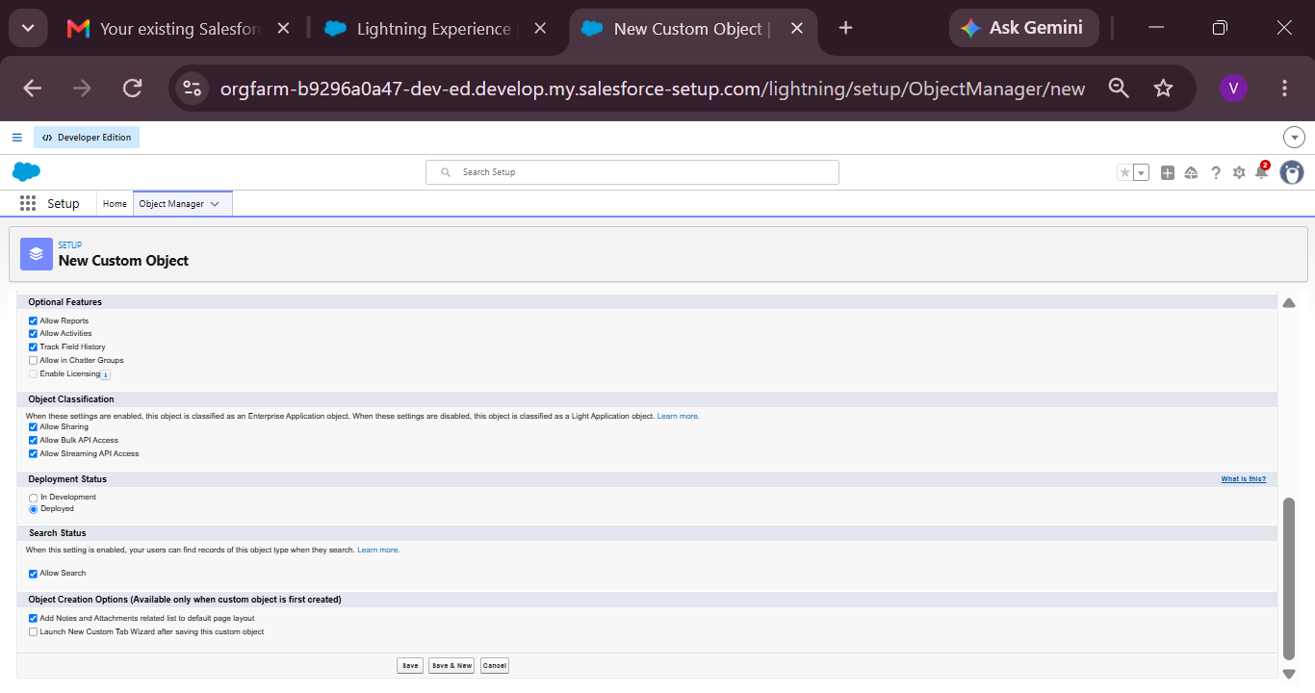

Activity 2: Create Shipment Object
Go to Setup → Object Manager → Create → Custom Object
Enter:
Label: Shipment
Plural Label: Shipments
Record Name: Tracking Number (Auto Number)
Example Format: SHP-{00000}
Starting Number: 0
Enable:
Allow Reports
Track Field History
Click Save

Activity 3: Create Delivery_Agent Object
Setup → Object Manager → Create → Custom Object
Enter:
Label: Delivery Agent
Plural Label: Delivery Agents
Record Name: Agent Name (Text)
Enable:
Allow Reports
Track Field History
Click Save
Activity 4: Create Branch Object
Setup → Object Manager → Create → Custom Object
Enter:
Label: Branch
Plural Label: Branches
Record Name: Branch Name (Text)
Enable:
Allow Reports
Click Save.

Activity 5: Create Delivery_Update Object
Setup → Object Manager → Create → Custom Object
Enter:
Label: Delivery Update
Plural Label: Delivery Updates
Record Name: Update Number (Auto Number)
Example Format: UPD-{0000}
Enter Starting number : 0
Enable:
Allow Reports
Track Field History
Click Save.
Activity 6: Create Invoice Object
Setup → Object Manager → Create → Custom Object
Enter:
Label: Invoice
Plural Label: Invoices
Record Name: Invoice Number (Auto Number)
Example Format: INV-{0000}
Enter Starting number: 0
Enable:
Allow Reports
Track Field History
Click Save

Milestone 3 - Tabs
Tab:
Tabs in Salesforce help users view the information at a glance. It displays the data of objects and other web content in the application.

Activity 1: Creating a Tab for Customer Object
Click Home, type Tabs in Quick Find, and select Tabs.
Under Custom Object Tabs, click New.
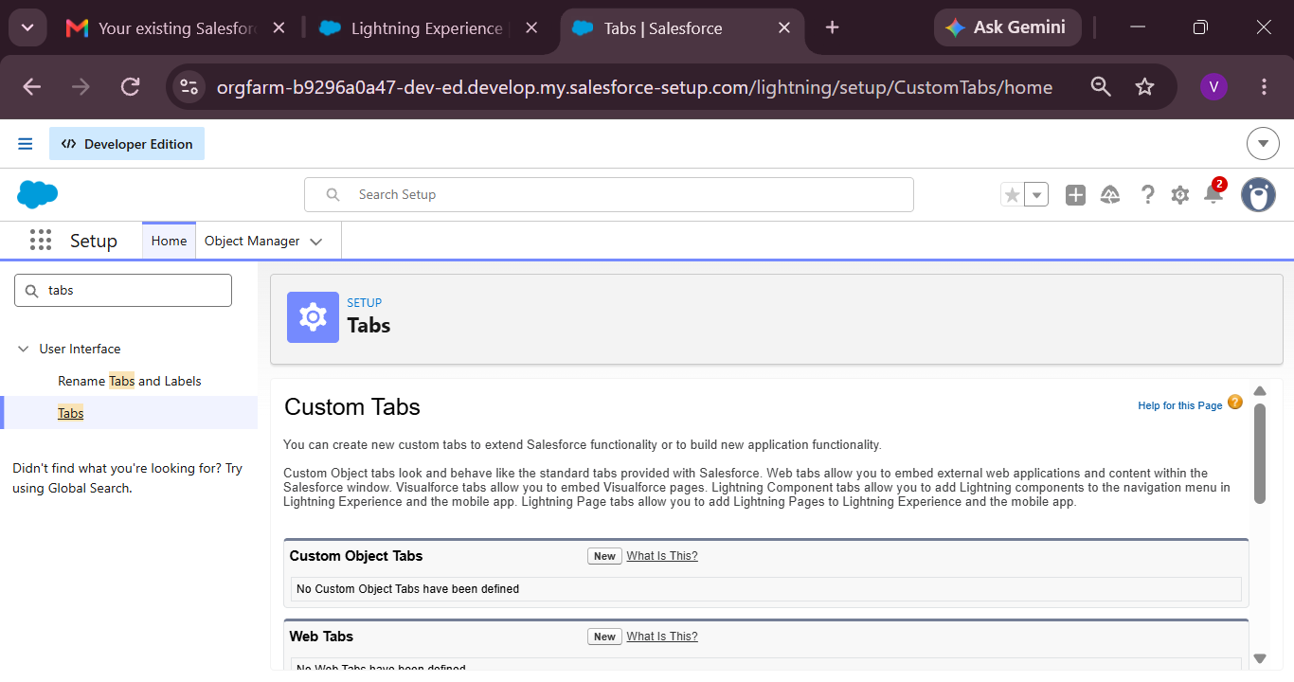
For Object, select Customer.
For Tab Style, choose any icon.
Leave all default settings as they are.
Click Next, Next, and Save.

Activity 2: Creating a Tab for Shipment Object
Click Home, type Tabs in Quick Find, and select Tabs.
Under Custom Object Tabs, click New.
For Object, select Shipment.
Choose any Tab Style.
Keep defaults unchanged.
Click Next, Next, and Save.

Activity 3: Creating a Tab for Delivery Agent Object
Click Home, type Tabs in Quick Find, and select Tabs.
Under Custom Object Tabs, click New.
For Object, select Delivery Agent.
Pick any Tab Style.
Leave default settings.
Click Next, Next, and Save.
Activity 4: Creating a Tab for Branch Object
Click Home, type Tabs in Quick Find, and select Tabs.
Under Custom Object Tabs, click New.
For Object, select Branch.
Choose any Tab Style.
Keep all defaults.
Click Next, Next, and Save.

Activity 5: Creating a Tab for Delivery Update Object
Click Home, type Tabs in Quick Find, and select Tabs.
Under Custom Object Tabs, click New.
For Object, select Delivery Update.
Select any Tab Style.
Keep default configurations.
Click Next, Next, and Save.

Activity 6: Creating a Tab for Invoice Object
Click Home, type Tabs in Quick Find, and select Tabs.
Under Custom Object Tabs, click New.
For Object, select Invoice.
Select any Tab Style.
Leave defaults unchanged.
Click Next, Next, and Save.

Milestone 4: Fields & Relationships
What are fields ?
Fields in Salesforce represent what the columns represent in relational databases. It can store
data values which are required for a particular object in a record.

Activity 1: Creation of fields for the Customer Object

Field Name | API Name | Data Type | Required | Description
Customer Name | Name | Text | Yes | Full name of customer
Email | Email__c | Email | Yes | Customer email
Phone | Phone__c | Phone | Yes | Customer contact number
Address | Address__c | Text Area | Yes | Customer address
Customer Type | Customer_Type__c | Picklist | Yes | Regular / Business
City | City__c | Text | No | Customer city
State | State__c | Text | No | Customer state
Pincode | Pincode__c | Text | No | Postal code
Is Active | Is_Active__c | Checkbox | No | Active status
1. Email (Email Field)
Go to Setup → Object Manager → Customer__c
Click Fields & Relationships → New
Select Email → Next
Field Label: Email
Check the Required box
Click Next → Next → Save
2. Phone (Phone Field)
Setup → Object Manager → Customer__c
Fields & Relationships → New
Select Phone → Next
Field Label: Phone
Check Required
Click Next → Next → Save
3. Address (Text Area)
Setup → Object Manager → Customer__c
Fields & Relationships → New
Select Textarea → Next
Field Label: Address
Check Required
Save
4. Customer Type (Picklist)
Setup → Customer__c → Fields → New
Picklist → Next
Field Label: Customer Type
Enter values:
Regular
Business
Check Required
Save
5. City (Text)
Setup → Customer__c → Fields → New
Text → Next
Field Label: City
Save
6. State (Text)
Setup → Customer__c → Fields → New
Text → Next
Field Label: State
Save
7. Pincode (Text)
Setup → Customer__c → Fields → New
Text → Next
Field Label: Pincode
Save
8. Is Active (Checkbox)
Setup → Customer__c → Fields → New
Checkbox → Next
Field Label: Is Active
Save

Activity 2: Creation of fields for the Shipment Object
Field Name | API Name | Data Type | Required | Description
Tracking Number | Name | Auto Number | Yes | Unique ID
Customer | Customer__c | Lookup(Customer) | Yes | Related customer
Source Address | Source_Address__c | Text Area | Yes | Pickup location
Destination Address | Destination_Address__c | Text Area | Yes | Delivery location
Weight | Weight__c | Number | Yes | Parcel weight
Price | Price__c | Currency | Yes | Shipping charge
Status | Status__c | Picklist | Yes | Shipment status
Expected Date | Expected_Date__c | Date | Yes | Delivery estimate
Assigned Agent | Assigned_Agent__c | Lookup(Delivery_Agent) | No | Delivery agent
Shipment Type | Shipment_Type__c | Picklist | Yes | Domestic/International

- Source Address (Text Area)
- Setup → Shipment__c → Fields → New
Textarea → Next
Field Label: Source Address
Required → Save
2. Destination Address (Text Area)
Setup → Shipment__c → Fields → New
Textarea → Next
Field Label: Destination Address
Required → Save
3. Weight (Number)
Setup → Shipment__c → Fields → New
Number → Next
Field Label: Weight
Required → Save
4. Price (Currency)
Setup → Shipment__c → Fields → New
Currency → Next
Field Label: Price
5. Status (Picklist)
Values:
Booked
In Transit
Out for Delivery
Delivered
Cancelled
Required → Save
6. Expected Date (Date)
Setup → Shipment__c → Fields → New
Date → Next
Field Label: Expected Date
Required → Save
7. Shipment Type (Picklist)
Values:
Domestic
Required → Save

Activity 3: Creation of fields for Delivery_Agent Object

Field Name | API Name | Data Type | Required
Agent Name | Name | Text | Yes
Email | Email__c | Email | Yes
Phone | Phone__c | Phone | Yes
Branch | Branch__c | Lookup | Yes
Status | Status__c | Picklist | Yes
Joining Date | Joining_Date__c | Date | No

1. Email
Email → Next
Field Label: Email
Required → Save
2. Phone
Setup → Delivery_Agent__c → Fields → New
Phone → Next
Field Label: Phone
Required → Save

3. Status (Picklist)
Values:
Active
Inactive
On Leave
Required → Save
4. Joining Date
Setup → Delivery_Agent__c → Fields → New
Date → Next
Field Label: Joining Date
Save

Activity 4: Creation of fields for Branch Object

Field Name | API Name | Data Type | Required
Branch Name | Name | Text | Yes
Branch Code | Branch_Code__c | Text | Yes
City | City__c | Text | Yes
State | State__c | Text | Yes
Manager Name | Manager_Name__c | Text | No

Create each field using:
Setup → Branch__c → Fields → New
Select respective Data Type
Enter Field Label
Save
(Repeat for all fields)

Activity 5: Creation of fields for Delivery_Update Object

Field Name | API Name | Data Type | Required
Update Number | Name | Auto Number | Yes
Shipment | Shipment__c | Master-Detail | Yes
Status | Status__c | Picklist | Yes
Update Date | Update_Date__c | DateTime | Yes
Remarks | Remarks__c | Text | No

Status Picklist Values:
In Transit
Out for Delivery
Delivered
Delayed
Required → Save

Activity 6: Creation of fields for Invoice Object

Field Name | API Name | Data Type | Required
Invoice Number | Name | Auto Number | Yes
Shipment | Shipment__c | Lookup | Yes
Amount | Amount__c | Currency | Yes
Invoice Date | Invoice_Date__c | Date | Yes
Payment Status | Payment_Status__c | Picklist | Yes

Payment Status Values
Paid
Unpaid
Pending
Required → Save

Relationships :

Child Object | Field | Parent Object | Type
Shipment | Customer__c | Customer | Lookup
Shipment | Assigned_Agent__c | Delivery_Agent | Lookup
Delivery_Agent | Branch__c | Branch | Lookup
Delivery_Update | Shipment__c | Shipment | Master-Detail
Invoice | Shipment__c | Shipment | Lookup

Relationship Creation Steps :

Activity 1 – Shipment → Customer
Setup → Shipment__c → Fields → New
Lookup Relationship
Related Object: Customer__c
Field Label: Customer
Save

Activity 2 – Shipment → Delivery Agent
Setup → Shipment__c
New → Lookup
Object: Delivery_Agent__c
Label: Assigned Agent
Save

Activity 3 – Delivery Agent → Branch
Setup → Delivery_Agent__c
New → Lookup
Related Object: Branch__c
Label: Branch
Save
Activity 4 – Delivery Update → Shipment
Setup → Delivery_Update__c
New → Master-Detail
Related Object: Shipment__c
Save

Activity 5 – Invoice → Shipment
Setup → Invoice__c
New → Lookup
Object: Shipment__c
Save
Milestone 5-Validation Rules :
Validation rules are applied when a user tries to save a record and are used to check if the data meets specified criteria. If the criteria are not met, the validation rule triggers an error message and prevents the user from saving the record until the issues are resolved.

Activity 1: Create Validation Rules on Customer__c
1. Validation Rule: Email Must Not Be Blank
Steps:
Click the Gear icon → Setup
Go to Object Manager
Search and select Customer__c
From the left menu, click Validation Rules
Click New
Rule Name: Email_Required
Check Active
In Error Condition Formula, paste:
ISBLANK(Email__c)

Click Check Syntax
Error Message: Email is required.
Error Location: Field → Email
Click Save.
2. Validation Rule: Phone Must Be 10 Digits
Steps:
Setup → Object Manager → Customer__c
Validation Rules → New
Rule Name: Validate_Phone_Number
Check Active
Formula:
LEN(Phone__c) <> 10

Check Syntax
Error Message: Phone number must be 10 digits.
Error Location: Field → Phone
Save
3. Validation Rule: Pincode Must Be 6 Digits
Steps:
Setup → Object Manager → Customer__c
Validation Rules → New
Rule Name: Validate_Pincode
Active → Yes
Formula:
LEN(Pincode__c) <> 6

Error Message: Pincode must be 6 digits.
Location: Field → Pincode
Save

Activity 2: Create Validation Rules on Shipment__c
1. Validation Rule: Weight Must Be Greater Than Zero
Steps:
Setup → Object Manager → Shipment__c
Click Validation Rules → New
Rule Name: Validate_Weight
Active → Checked
Formula:
Weight__c <= 0

Check Syntax
Error Message: Weight must be greater than zero.
Location: Field → Weight
Save
2. Validation Rule: Price Must Be Greater Than Zero
Steps:
Setup → Object Manager → Shipment__c
Validation Rules → New
Rule Name: Validate_Price
Active → Yes
Formula:
Price__c <= 0

Error Message: Price must be greater than zero.
Location: Field → Price
Save
3. Validation Rule: Expected Date Cannot Be in the Past
Steps:
Setup → Object Manager → Shipment__c
Validation Rules → New
Rule Name: Validate_Expected_Date
Formula:
Expected_Date__c < TODAY()

Check Syntax
Error: Expected delivery date cannot be in the past.
Location: Field → Expected Date
Save

Activity 3: Create Validation Rules on Delivery_Agent__c
1. Validation Rule: Email Must Be Valid
Steps:
Setup → Object Manager → Delivery_Agent__c
Validation Rules → New
Rule Name: Validate_Agent_Email
Active → Yes
Formula:
NOT(CONTAINS(Email__c, "@"))

Error Message: Enter a valid email address.
Location: Field → Email
Save

Activity 4: Create Validation Rules on Branch__c
1. Validation Rule: Branch Code Must Not Be Blank
Steps:
Setup → Object Manager → Branch__c
Validation Rules → New
Rule Name: Branch_Code_Required
Formula:
ISBLANK(Branch_Code__c)

Error Message: Branch Code is mandatory.
Location: Field → Branch Code
Save

Activity 5: Create Validation Rules on Delivery_Update__c
1. Validation Rule: Remarks Required If Status is Delayed
Steps:
Setup → Object Manager → Delivery_Update__c
Validation Rules → New
Rule Name: Remarks_Required_For_Delay
Formula:
AND(
ISPICKVAL(Status__c, "Delayed"),
ISBLANK(Remarks__c)
)

Error Message: Remarks are required when status is Delayed.
Location: Field → Remarks
Save

Milestone 6 - Page Layouts :
Page Layouts in Salesforce control what a user sees on a record page and how information is organized.
They help structure fields, sections, buttons, related lists, and other components in a clean and user-friendly way.
By customizing page layouts, we ensure that users can easily enter, update, and view the required data.

Activity 1: Edit Page Layout for Customer__c
Steps:
Setup → Object Manager → Customer__c
Click Page Layouts
Click the default layout (usually Customer Layout)
Sections to Add & Arrange:
Open the default layout
In the top palette, click “Section”
Drag the Section and drop it anywhere on the layout
A pop-up appears → Fill details:
Section Name: “Customer Information”
Layout:
1-Column or
2-Column (recommended)
Tab-Key Order: Top-Down
Click OK
The new section will appear on the layout.
Drop fields inside the section (it will highlight).
Repeat the same for each field.
Section 1: Customer Information
Customer Name
Customer Type
Email
Phone
Is Active
Section 2: Address Details
Address
City
State
Pincode
Edit the layout as needed
Click Save.

Activity 2: Edit Page Layout for Shipment__c
Steps:
Setup → Object Manager → Shipment__c
Click Page Layouts
Open the default Shipment Layout
Sections to Add:
Section 1: Shipment Details
Tracking Number
Customer
Shipment Type
Weight
Price
Status
Section 2: Address Information
Source Address
Destination Address
Section 3: Delivery Information
Expected Date
Assigned Agent
Arrange fields properly
Click Save
Activity 3: Edit Page Layout for Delivery_Agent__c
Steps:
Setup → Object Manager → Delivery_Agent__c
Page Layouts
Open default Delivery Agent Layout
Arrange Fields:
Agent Details
Agent Name
Email
Phone
Branch
Status
Joining Date
Additional Information
Related Shipments
Related Delivery Updates
Edit → Save
Activity 4: Edit Page Layout for Branch__c
Steps:
Setup → Object Manager → Branch__c
Page Layouts
Open default Branch Layout
Sections:
Branch Information
Branch Name
Branch Code
City
State
Manager Name
Arrange fields
Click Save

Activity 5: Edit Page Layout for Delivery_Update__c
Steps:
Setup → Object Manager → Delivery_Update__c
Page Layouts
Open default Delivery Update Layout
Sections:
Update Information
Update Number
Shipment
Status
Update Date
Remarks
Arrange properly
Click Save
Activity 6: Edit Page Layout for Invoice__c
Steps:
Setup → Object Manager → Invoice__c
Page Layouts
Open default Invoice Layout
Sections:
Invoice Details
Invoice Number
Shipment
Amount
Invoice Date
Payment Status
Arrange fields as needed
Click Save
Milestone 7 - Flows
In Salesforce, a flow is a powerful tool that allows you to automate business processes, collect and update data, and guide users through a series of screens or steps. Flows are built using a visual interface and can be created without any coding knowledge.

Activity 1: Auto-Update Shipment Status When Delivery Update is Created
Scenario:
Whenever a Delivery_Update__c record is created, automatically update the related Shipment__c Status with the latest status from Delivery Update.
Part 1: Create the Record-Triggered Flow
Step 1: Open Flow Builder
Click the Gear Icon → Click Setup
In the Quick Find box (left side), type Flows
Click Flows
Click the New Flow button
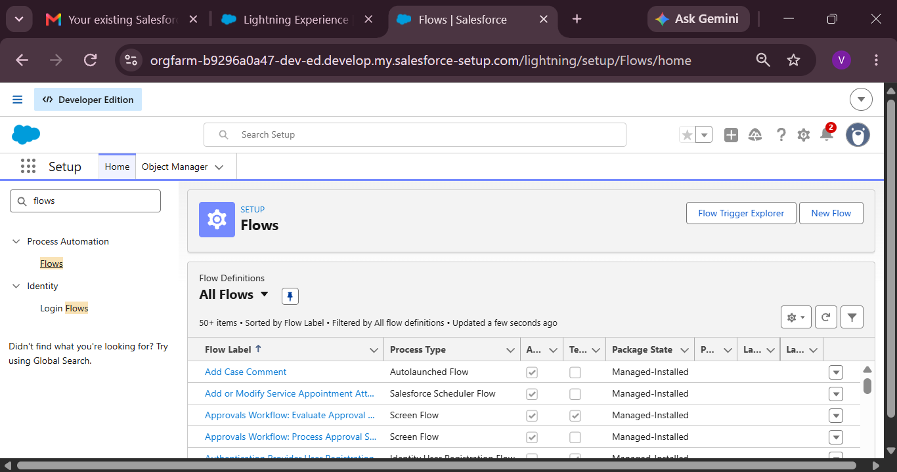
Select Record-Triggered Flow
Click Create
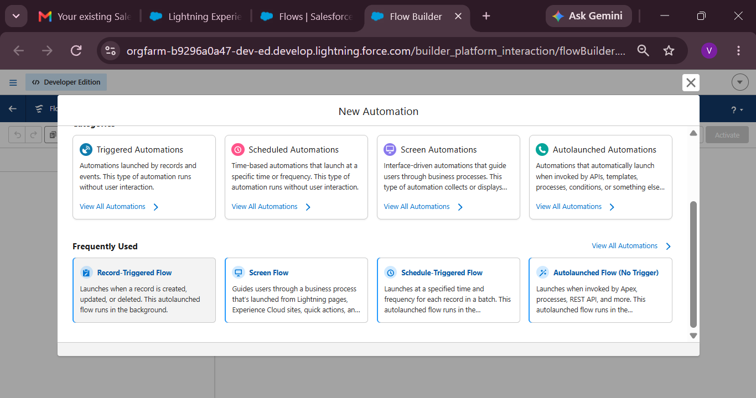
Step 2: Configure the Start (Trigger)
On the Start panel on the right:
Object: select Delivery_Update__c
Trigger the Flow When:
Select A record is created
Condition Requirements:
Choose: None (Always Run the Flow)
Optimize the Flow For:
Select Actions and Related Records
Click Done
Part 2: Update Related Shipment Record
Step 3: Add “Update Records” Element
Click the + icon under the Start element
Select Update Records
Configure the Update Records Element:
Label: Update_Shipment_Status
How to Find Records to Update:
Select Specify conditions to identify records
Set Filter Conditions:
Object: Shipment__c
Field: Id
Operator: Equals
Value: {!$Record.Shipment__c}
(This means update the Shipment linked to the Delivery Update)
Set Field Values to Update
Add field mapping:
Shipment Field | Value Source
Status__c | {!$Record.Status__c}

(This copies status from Delivery Update to Shipment)
Click Done
Part 3: Save and Activate
Step 4: Save Flow
Save (top-right)
Flow Label: Auto_Update_Shipment_Status
API Name will auto-fill
Click Save
Step 5: Activate Flow
Click Activate
Flow status should show Active
Final Flow Layout:
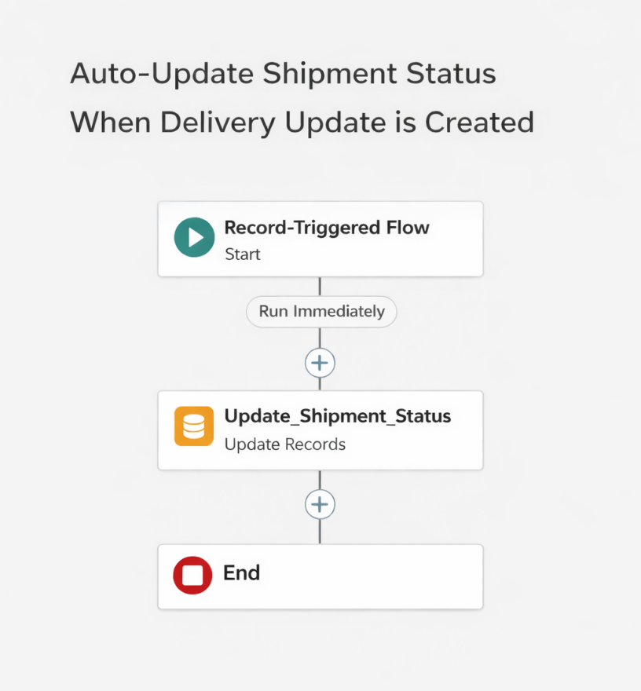

Milestone 8 - The Lightning App :
What is an App ?
Apps in Salesforce are a group of tabs that help the application function by working together
as a unit. It has a name, a logo, and a particular set of tabs. The simplest app usually has just
two tabs.

Activity 1: Create a Lightning App
Create the Courier Management System App
From Setup, enter App Manager in the Quick Find and select App Manager.
Click New Lightning App.
Enter the Courier Management System as the App Name.
Upload an image or icon for the app, then click Next.
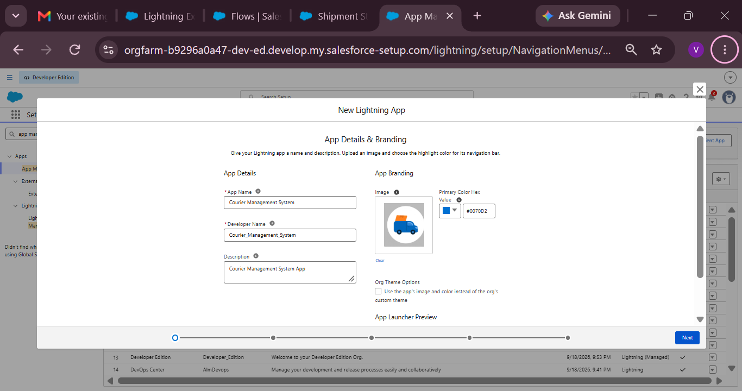
Under App Options, leave the default selections and click Next.
Under Utility Items, leave as it is and click Next.
From Available Items, select the following and move them to Selected Items:
Customer

Shipment
Delivery Agent
Branch
Delivery Update
Invoice
Reports
Dashboards
Click Next.
From Available Profiles, select System Administrator and move it to Selected Profiles.
Click Save & Finish.
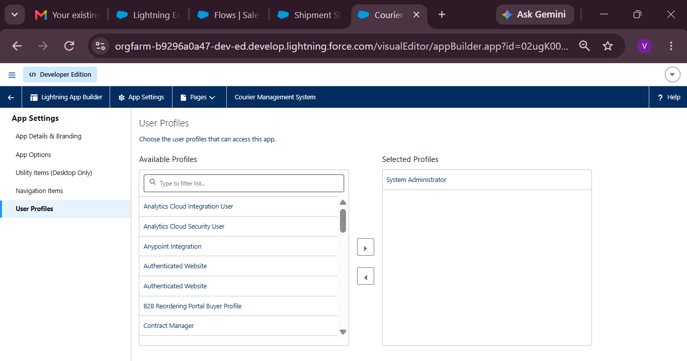

Milestone 9- Profile:
What is a profile?
A profile is a group/collection of settings and permissions that define what a user can do in salesforce. A profile controls “Object permissions, Field permissions, User permissions, Tab
settings, App settings, Apex class access, Visualforce page access, Page layouts, Record Types,
Login hours & Login IP ranges.
A profile can be assigned to many users, but users can be assigned a single profile at a time.

Activity 1: Create a Custom Profile – Courier Admin
Create a Custom Profile:
From Setup, enter Profiles in the Quick Find box.
Click Profiles.
Click New Profile.
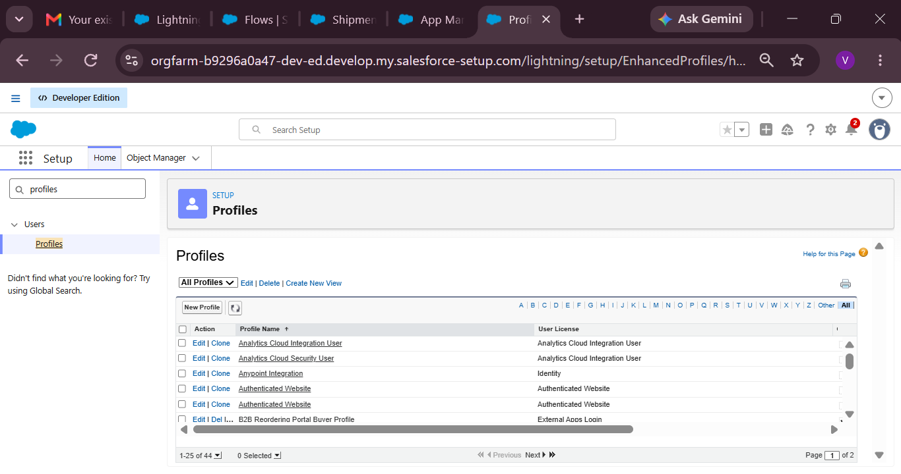
Select Existing Profile as: System Administrator.
Enter Profile Name: Courier Admin.
Click Save.
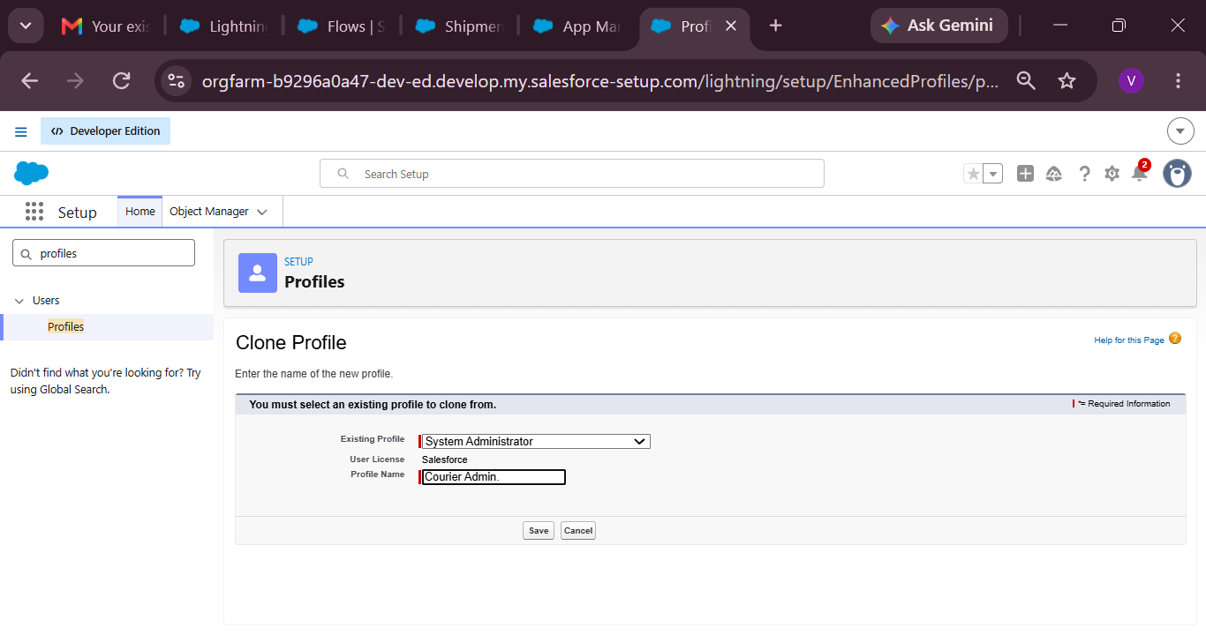
Why use System Administrator as Base?
It already has:
Modify All Data
Customize Application
Full CRUD access on all objects
By cloning it, the Courier Admin profile automatically inherits full access.
You can later restrict permissions if required.

Activity 2: Create a Custom Profile – Branch Manager
Steps:
From Setup, enter Profiles in the Quick Find box.
Click Profiles.
Click New Profile.
Select Existing Profile as: Standard Platform User.
Enter Profile Name: Branch Manager.
Click Save.
Click Edit on the Branch Manager profile.
Set App & Tab Settings
Under Assigned Apps / Custom App Settings, set the default app to:
Courier Management System App
Ensure Visible Tabs Include:
Set these tabs as Default On or Visible:
Customers
Shipments
Delivery Agents
Branches
Delivery Updates
Invoices
Reports
Dashboards
Custom Object Permissions
Scroll to Custom Object Permissions and set access as follows:
Object | Permissions to Grant
Customer__c | Create, Read, Edit
Shipment__c | Create, Read, Edit
Delivery_Agent__c | Read, Edit
Branch__c | Read, Edit
Delivery_Update__c | Create, Read, Edit
Invoice__c | Read
Session & Password Settings
Under Session Settings:
Session Timeout: 2 Hours of Inactivity
Under Password Policies:
User passwords expire in: Never Expires
Minimum Password Length: 8
Click Save.

Activity 3: Create a Custom Profile – Delivery Agent
Steps:
Setup → Quick Find → Profiles
Click New Profile
Existing Profile: Standard Platform User
Profile Name: Delivery Agent
Click Save
App & Tab Access
Default App: Courier Management System
Visible Tabs:
Shipments
Delivery Updates
Object Permissions :
Object | Permissions
Shipment__c | Read, Edit
Delivery_Update__c | Create, Read, Edit
Customer__c | Read
Invoice__c | Read
Restrictions
No access to Branch editing
No delete permissions
Limited reporting access
Click Save.

Activity 4: Create a Custom Profile – Customer Support
Steps:
Setup → Profiles → New Profile
Base Profile: Standard User
Profile Name: Customer Support
Access Configuration
Tabs Visible:
Customers
Shipments
Delivery Updates
Object Permissions :
Object | Access
Customer__c | Read, Edit
Shipment__c | Read, Edit
Delivery_Update__c | Read
Invoice__c | Read
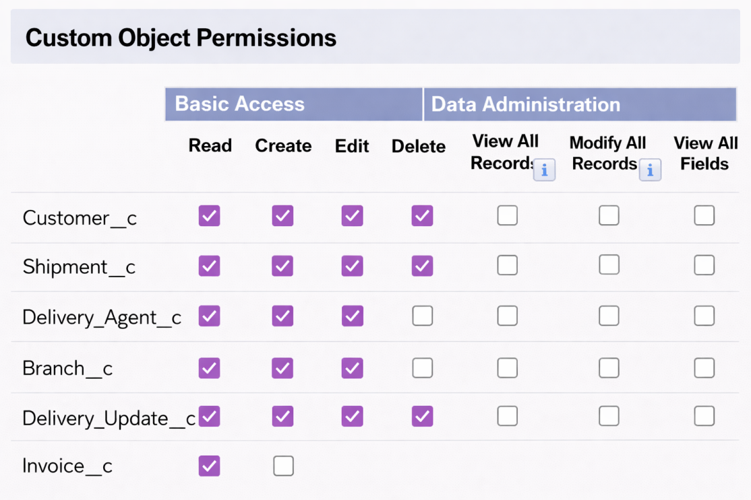
Session Settings
Session Timeout: 2 Hours
Password Length: 8
Click Save
Final Profiles Created in Project :
Profile Name | Purpose
Courier Admin | Full system control
Branch Manager | Manage shipments and agents
Delivery Agent | Update delivery status
Customer Support | Handle customers and tracking

Milestone 10- Role:
In Salesforce, roles are used to determine which users have access to certain data and functions within the system. They are also used to define the reporting hierarchy within an organization. Users with higher roles have greater access to data and more control over the system.

Activity 1: Creation of Courier Admin Role
Creation of Role:
From the Quick Find box, search for Roles and click on the Roles option.
Select Set Up Roles.
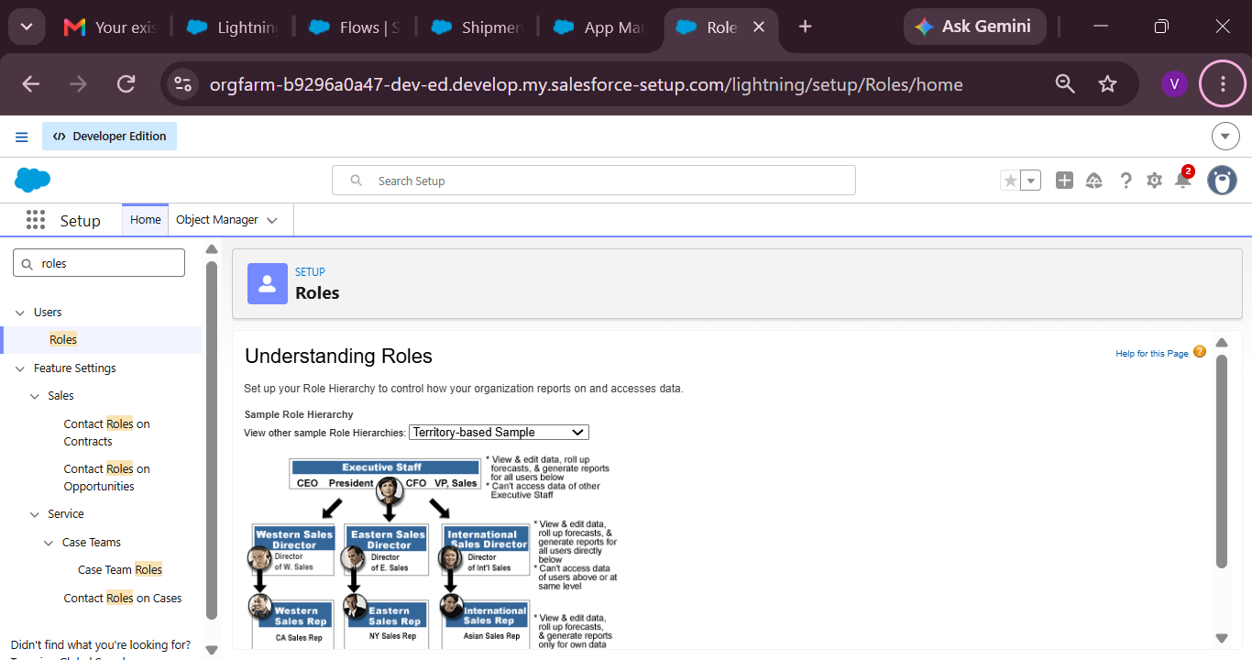
Click on Expand All and click Add Role under CEO.
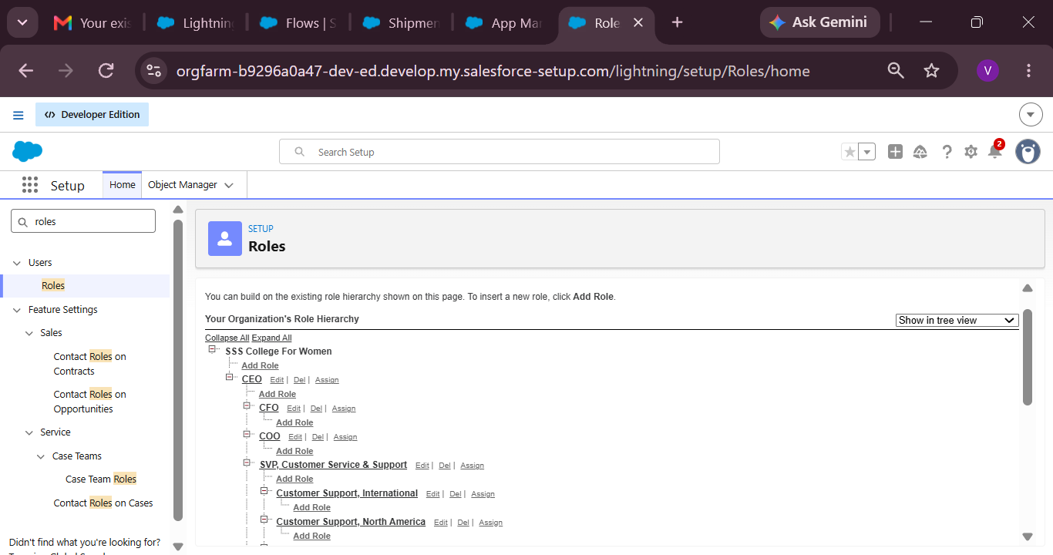
Give Label as “Courier Admin”.
The Role Name will auto-populate.
Click Save.

Activity 2: Creating Branch Manager Role Under Courier Admin Role
Create another role:
Create a role with the name “Branch Manager”.
Below the Courier Admin, click on Add Role.
Enter the label name as “Branch Manager” and the Role Name will automatically populate.
Click Save.

Activity 3: Creating Delivery Agent Role Under Branch Manager Role
Steps:
Below the Branch Manager role, click on Add Role.
Enter Label as “Delivery Agent”.
Role Name will auto-populate.
Click Save.

Activity 4: Creating Customer Support Role Under Branch Manager
Steps:
Under the Branch Manager role, click on Add Role.
Enter Label as “Customer Support”.
Role Name will automatically populate.
Click Save.
Purpose of This Hierarchy :
Courier Admin – Highest level access to all data
Branch Manager – Manages branch-level operations
Delivery Agent – Access only to assigned shipments
Customer Support – Limited access to customer and shipment tracking
This hierarchy ensures proper data sharing and security in the Courier Management System.

Milestone 11- User :

What is a user?

A user is anyone who logs in to Salesforce. Users are employees at your company, such as sales,reps, managers, and IT specialists, who need access to the company's records. Every user in Salesforce has a user account. The user account identifies the user, and the user account settings determine what features and records the user can access.

NOTE- As Salesforce license can only be used by 2 Users at a time in Dev Org, So If you don’t find a salesforce license then deactivate a user who has a salesforce license Or change the license type from Salesforce to any other.

Activity 1: To Create a User
Steps:
From Setup, enter Users in the Quick Find box, then select Users.
Click New User.
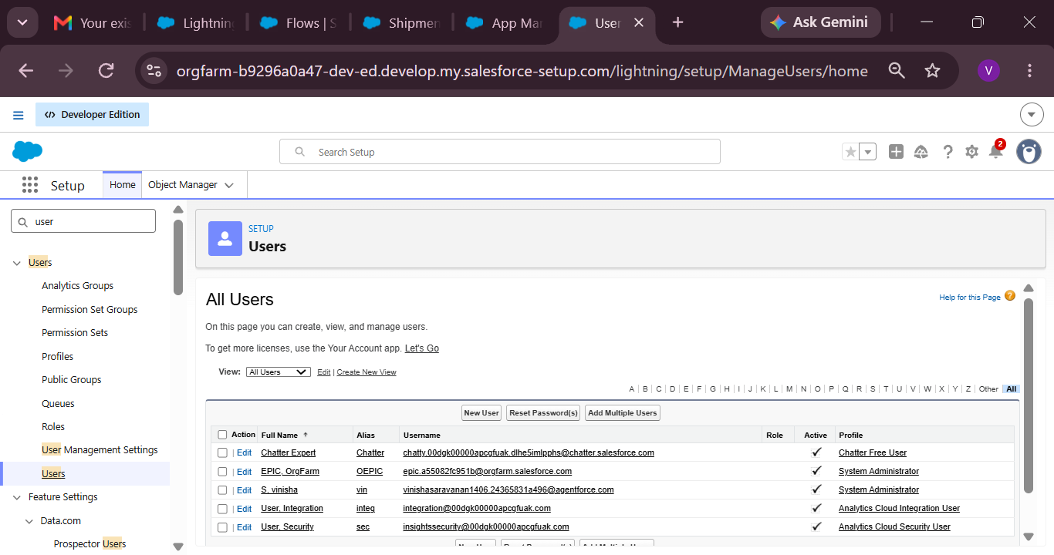
Fill in the Fields:

Field Name | Value
First Name | Enter first name (Example: Ravi)
Last Name | Enter last name (Example: Kumar)
Alias | Give an alias name
Email ID | Enter your personal email ID
Username | Must be in the format: text@text.text and must be unique
Nickname | Give a nickname
Role | Select Courier Admin
User License | Salesforce
Profile | Courier Admin

3. Click Save.

Activity 2: Creating Other Users
Repeat the same steps as Activity 1 for creating additional users.
Use the following details:
User Type | Role | User License | Profile
Branch Manager | Branch Manager | Salesforce | Branch Manager
Delivery Agent | Delivery Agent | Salesforce Platform | Delivery Agent
Customer Support | Customer Support | Salesforce Platform | Customer Support

Example:
To create a Branch Manager User:
Go to Setup → Users → New User
Fill details like:

Field | Example Value
First Name | Arjun
Last Name | Reddy
Email | arjun@gmail.com
Username | arjun.manager@cms.com
Role | Branch Manager
Profile | Branch Manager
Click Save
To Create Delivery Agent User:
Follow same steps with:
Role: Delivery Agent
Profile: Delivery Agent

To Create Customer Support User:
Role: Customer Support
Profile: Customer Support
Important Points
Every user must have:
Unique username
Valid email
Assigned Role
Assigned Profile
Profiles control permissions
Roles control data visibility

Milestone 15 : Reports & Dashboards
Reports and Dashboards help analyze business data and track courier operations efficiently.

Activity 1: Create Report Types
Step 1: Open Report Types
Click Gear Icon → Select Setup.
In Quick Find search Report Types.
Click New Custom Report Type.
Step 2: Create Shipment Report Type
Primary Object: Shipment__c
Label: Shipment Tracking Report
Category: Reports
Deployment Status: Deployed
Click Next → Save
Step 3: Create Customer Report Type
Primary Object: Customer__c
Label: Customer Summary Report
Category: Reports
Deployment Status: Deployed
Click Next → Save
Step 4: Create Agent Performance Report Type
Primary Object: Delivery_Agent__c
Label: Agent Performance Report
Category: Reports
Deployment Status: Deployed
Click Next → Save

Activity 2: Create Reports
Report 1: Shipment Status Summary Report
Step 1: Create the Report
Click App Launcher (9 dots) → Search Reports
Click New Report
Choose Shipment Tracking Report
Click Continue
Step 2: Add Columns
Add these fields:
Tracking Number
Customer
Status
Expected Date
Assigned Agent
Step 3: Add Filters
Show Me: All Shipments
Date Filter: This Month
Status Filter: Select specific Status (Optional)
Step 4: Group & Summarize
Group rows by Status__c
Add summary on Price
Step 5: Save Report
Click Save & Run
Name: Shipment Status Summary
Folder: CMS Reports
Report 2: Agent Performance Report
Step 1: Create Report
New Report → Choose Agent Performance Report
Click Continue
Step 2: Add Columns
Agent Name
Branch
Number of Shipments
Status
Step 3: Group Data
Group by Delivery_Agent__c
Step 4: Save Report
Name: Agent Performance Report
Folder: CMS Reports
Save & Run
Report 3: Revenue Report
Steps
Create report using Shipment Tracking Report Type
Add fields:
Tracking Number
Customer
Price
Invgoice Status
T6Group by:
Branch
Month
Save as: Revenue by Branch Report

Activity 3: Create Dashboard
Step 1: Open Dashboards
Click App Launcher (9 dots)
Search Dashboards
Click New Dashboard
Step 2: Enter Dashboard Details
Name: Courier Management Dashboard
Folder: CMS Reports
Click Create

Activity 4: Add Dashboard Components
Component 1: Shipment Status Overview (Donut Chart)
Click + Component
Choose report: Shipment Status Summary
Visual Type: Donut Chart
Click Add
Component 2: Agent Performance (Bar Chart)
Select report: Agent Performance Report
Chart Type: Bar Chart
Click Add
Component 3: Revenue by Branch (Column Chart)
Choose report: Revenue by Branch Report
Chart Type: Column Chart
Click Add
Activity 5: Save & Activate Dashboard
Click Save
Click Done
Share Dashboard With:
Courier Admin
Branch Managers
Customer Support Team
Final Layout :
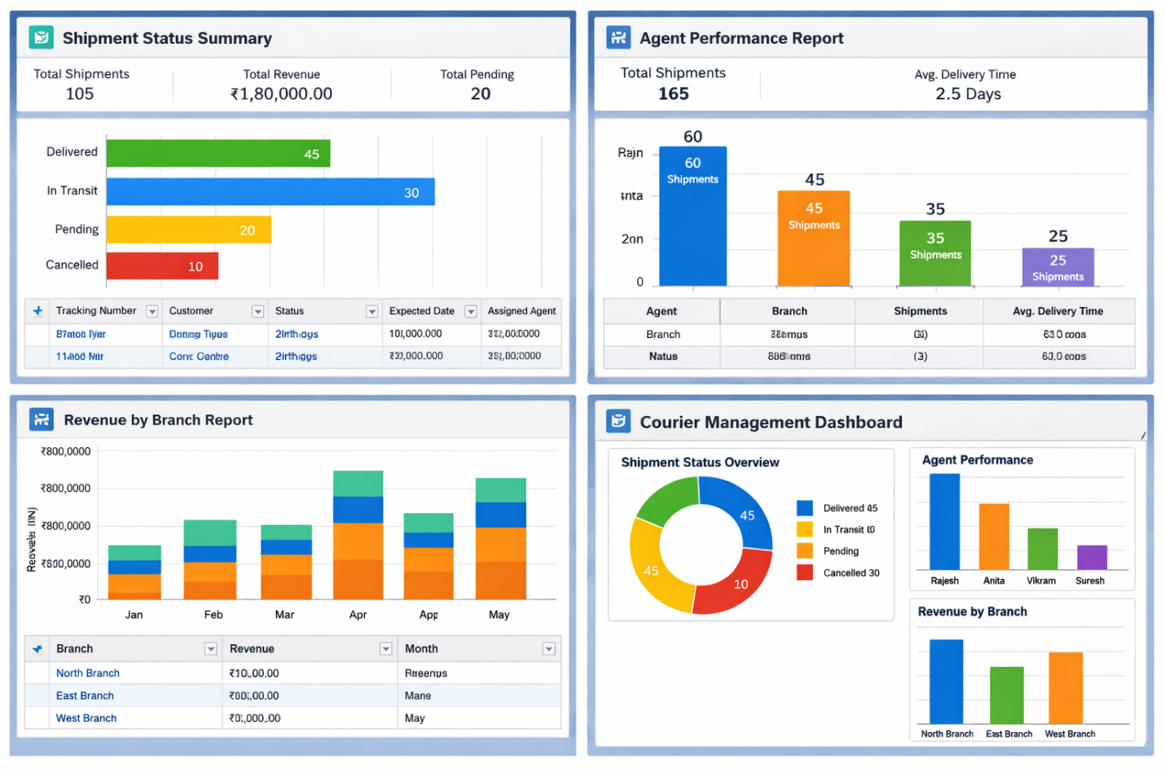

7. FUNCTIONAL & PERFORMANCE TESTING

During testing, screenshots were captured from Salesforce to verify record creation, validation rule enforcement, delivery status updates, flow automation, invoice generation, and dashboard visualization. All scenarios were validated to ensure correct performance and reliability.

8. ADVANTAGES & DISADVANTAGES

Advantages
Centralized data
Automated workflows
Real-time reporting
Disadvantages
Salesforce dependency
Requires initial configuration effort

9. Conclusion:

The Courier Management System successfully digitizes courier operations using Salesforce automation, improving efficiency, accuracy, and customer satisfaction.

10. FUTURE SCOPE
Mobile tracking app
GPS integration
SMS notifications
AI-based delivery optimization

11. APPENDIX
Source Code: Salesforce Configuration
Dataset: Salesforce Objects
GitHub / Demo: Salesforce Developer Org

Thank You

